Ultimate Tic-Tac-Toe User Guide

**Navigating the site:**

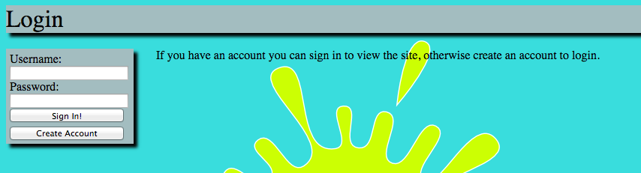

* First you will need to log in. If you don’t have an account you’ll need to create one. You can do this by clicking the “Create Account” button.

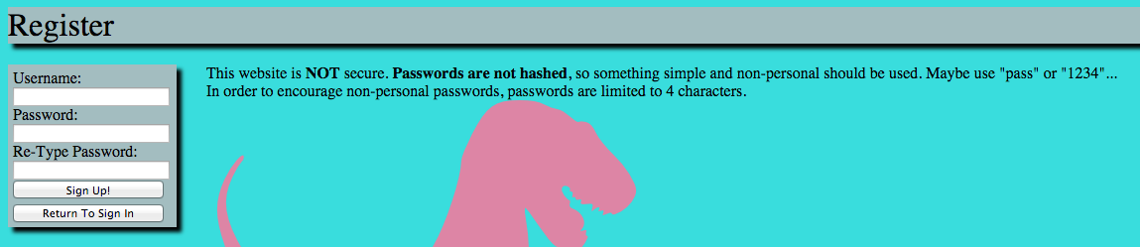

* Enter in a username and a password as instructed and click “Sign up!”
* Now log in with your username and password.
* There are three main pages: Ultimate Tic-Tac-Toe, Forum, and Search.

Ultimate Tic-Tac-Toe

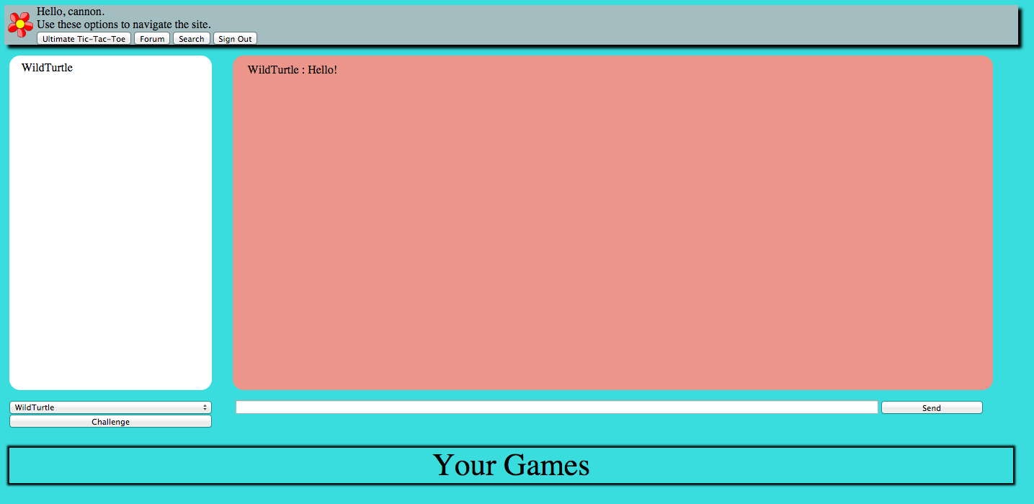

* You can see who is online, chat with those players, and challenge those players to games. You can also see your active and pending games.
* To enter a message, enter your message in the space provided and click “Send”
* To challenge someone to a game, select their name from the drop down menu and click “Challenge!”

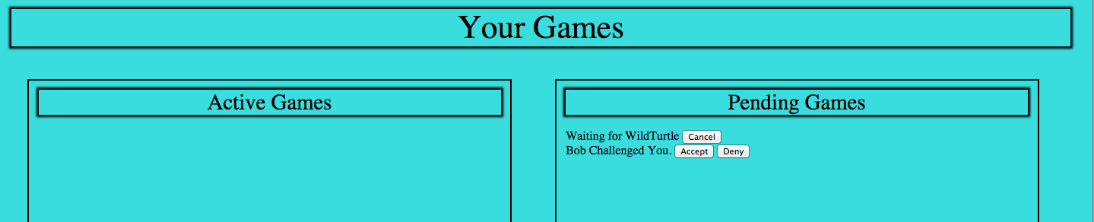

* If you challenge someone, you can cancel the challenge while it is pending.
* If someone challenges you, you can either accept or deny the challenge.



* When you have an active game, you can go to that game by clicking “Go to game with *username*”

Forums

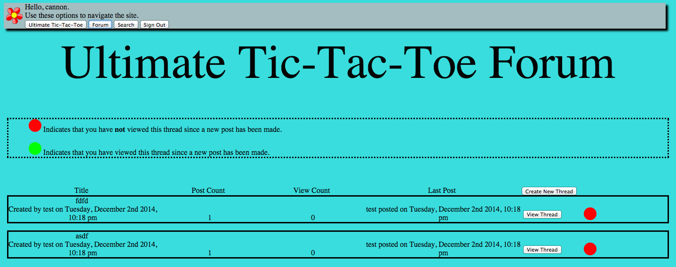

* Here you can create and view threads.

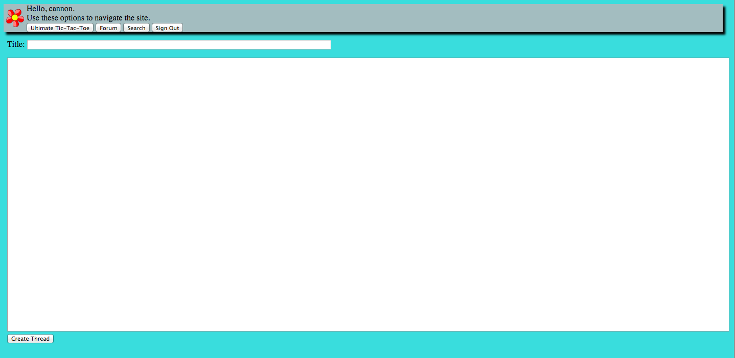

* To create a thread click “Create New Thread”
  + Enter the title and your message and click “Create Thread”



* To view a thread, click “View Thread”
  + If you have viewed all posts in the thread there will be a green circle, if not there will be a red circle.
  + Here you can post a reply to the thread by clicking “Post Reply”

Search

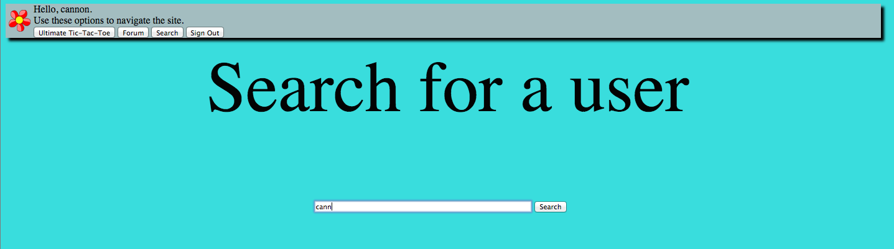

* Enter in part or all of a user’s name a click search to find the user you are looking for!

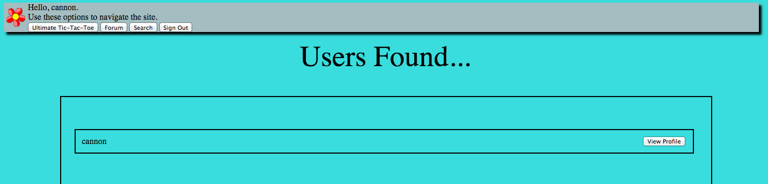

**Playing the game**

Ultimate Tic-Tac-Toe is set up like a regular game of Tic-Tac-Toe, but with a game set up in each space. Like so:

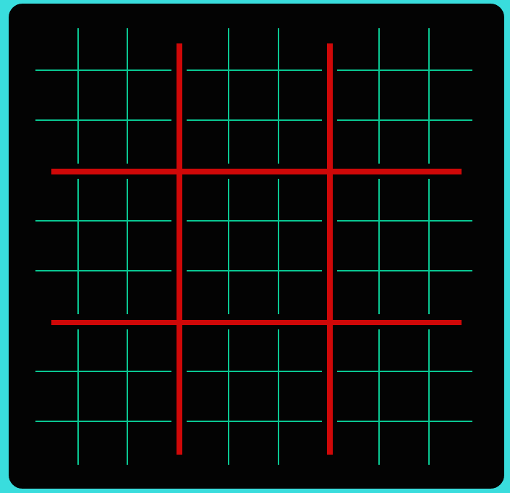

Each player takes a turn placing one X or O at a time. However, the player can only go in the large space that corresponds with the space played by the player before.

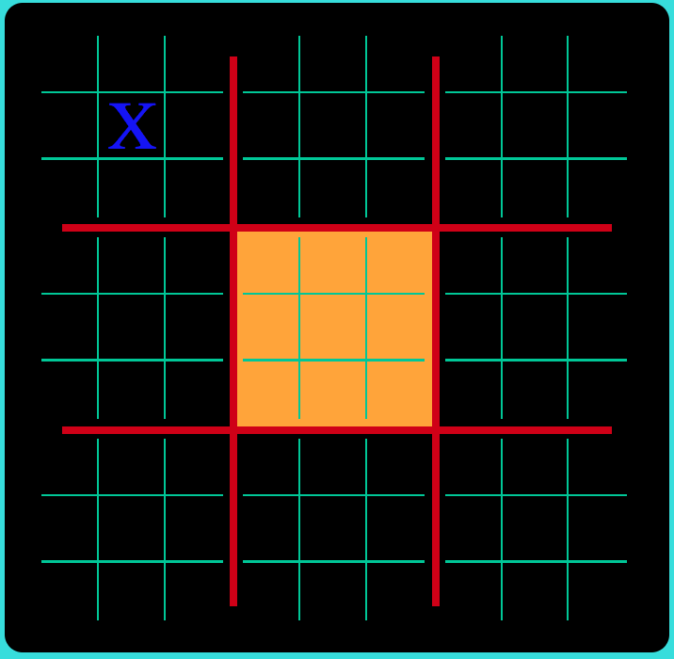

Because the first player placed the X in the middle of one of the small games, the next player must go in the middle of the large space.

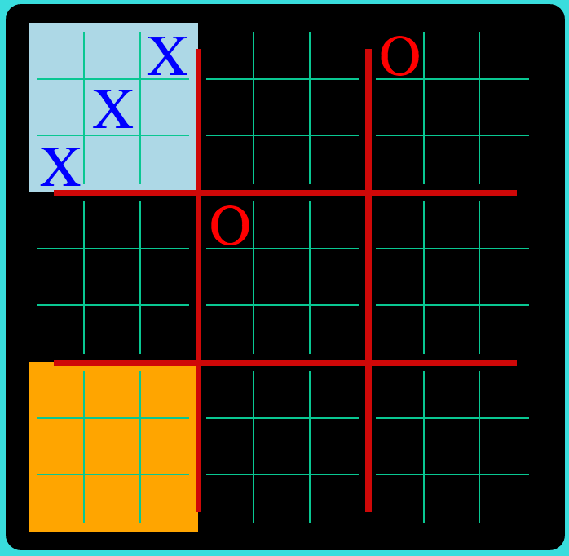

If a player wins a small game, they get that space in the larger game.

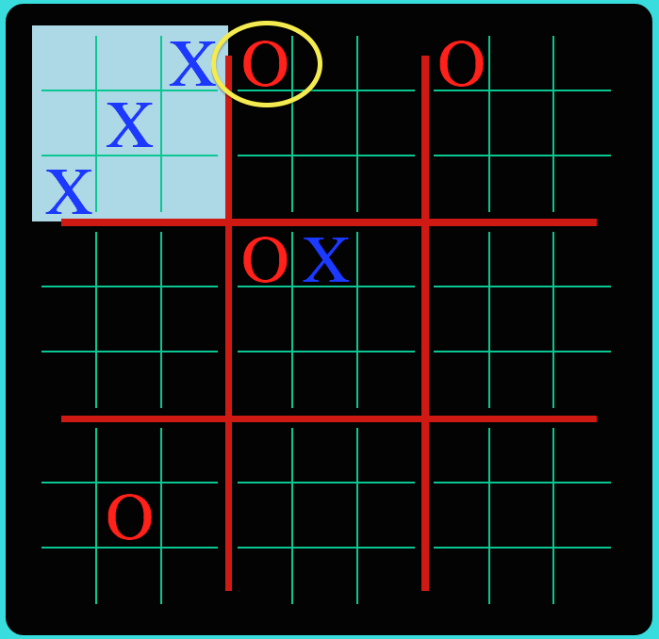

If a player goes in a space where the larger game is already won, the following player can go in any of the larger game spaces.

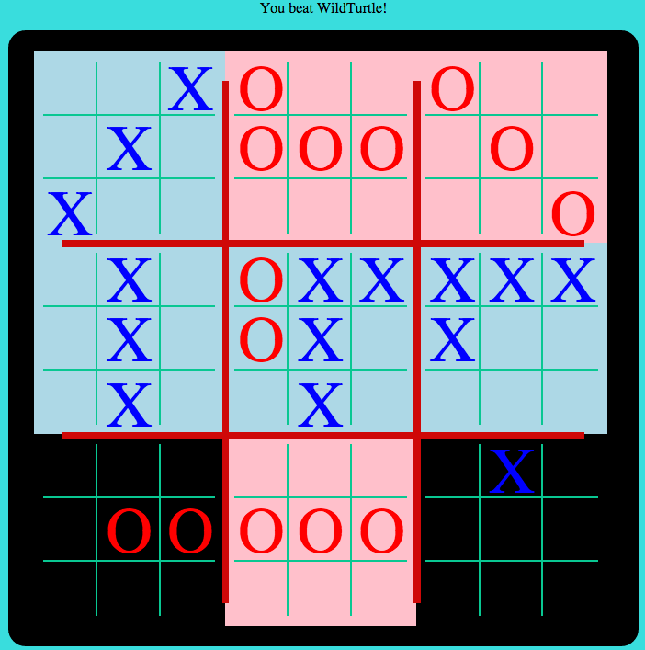

The game ends when a player wins the large game, or if the game results in a draw.